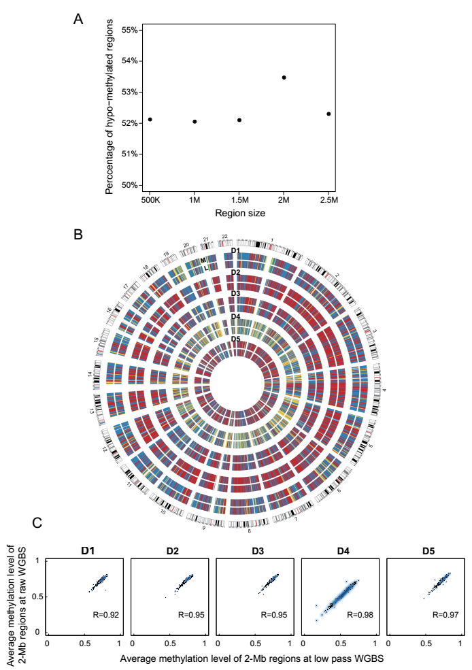

**Fig. S1. Determination of optimal region size and effective sequencing depth of low pass WGBS.** (A) Percentage of hypo-methylated regions at 500-Kb, 1-Mb, 1.5-Mb, 2-Mb and 2.5-Mb size in the HCC patient (D4). (B) Comparison of average methylation level of 2-Mb regions between 5M re-sampling reads and total sequencing reads from 5 individuals. Genome-wide DNA methylation level of 2-Mb regions for each comparison are shown in circos. The data represent the average methylation levels for 2-Mb regions. “M” represents the total WGBS and “L” represents the 5M re-sampling reads from total WGBS. Colors represent (from green, purple, yellow, blue and red) the methylation level from low to high. (C). The correlation of average methylation level of 2-Mb regions between 5M re-sampling reads and total sequencing reads. The Pearson’s correlation coefficient is large than 0.92 in all the 5 samples.

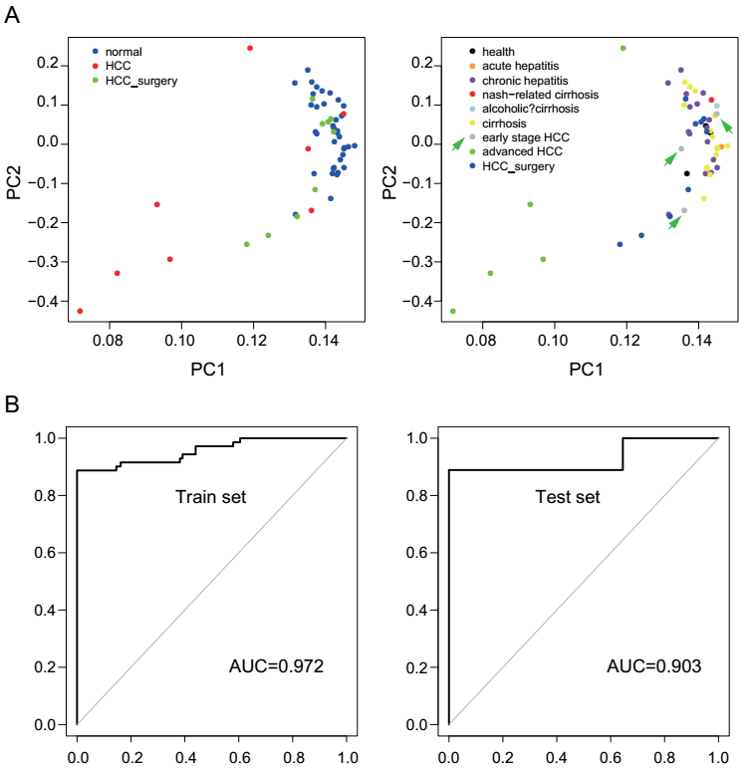

**Fig. S2. Low pass WGBS of cell free DNA distinguishes HCC from cirrhosis, hepatitis and healthy individuals.** (A) PCA based on average methylation level of 2-Mb region of all the samples. (B) Neural network analysis to the top 10 features selected by RF in training dataset**.**

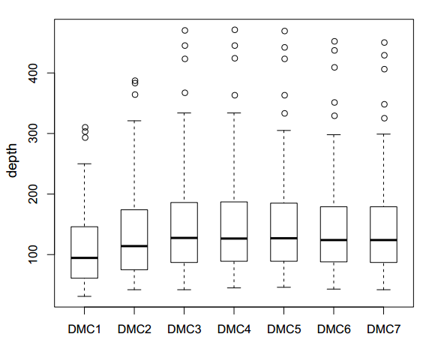

**Fig. S3. The depth of 7 DMCs of SENP5 in all the samples.**

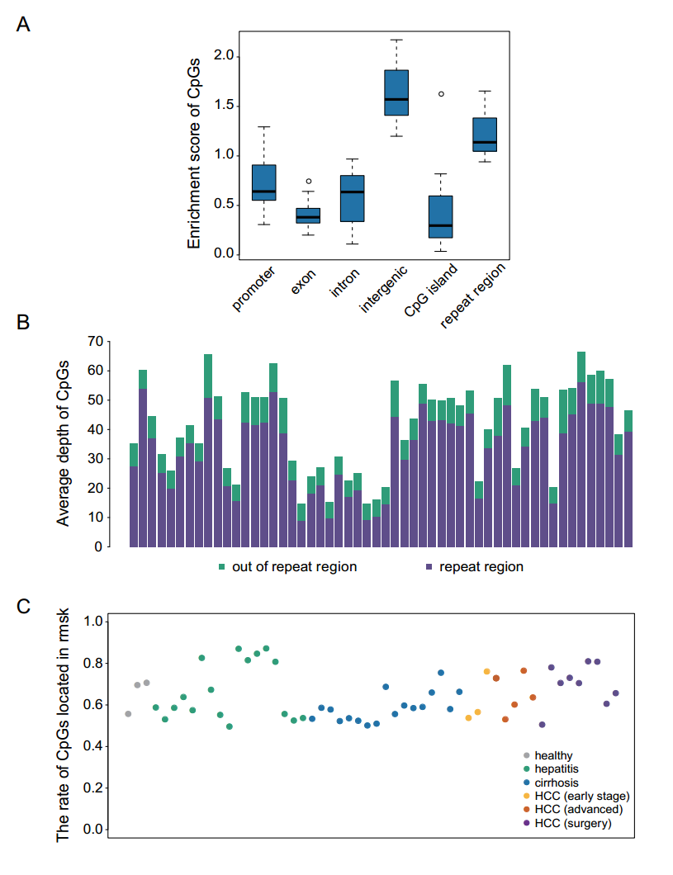

**Fig. S4. The genome feature distribution of CpGs at the low-pass WGBS.** (A) The enrichment scores of CpGs in promoter, exon, intron intergenic, CpG island and repeat regions of all the samples. (B) The average depth of CpGs located in repeat regions and CpGs located outside of repeat regions. (C) The percentage of CpGs located in repeat regions in all the individuals.

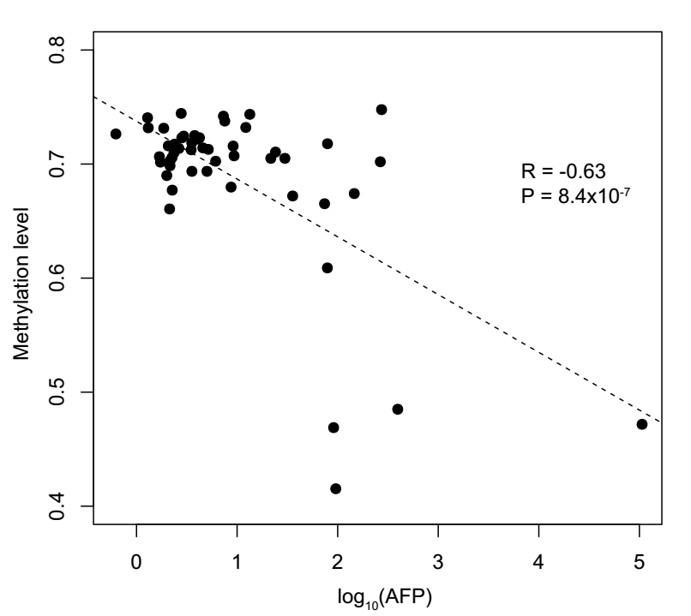

**Fig. S5. The correlation between AFP (log10) and average methylation level of the CpGs within the 100bp of the reported HBV integration sites (MethylHBV).**